**Name**: Jenna Laaksovirta

**Pair:**

**Amount of completed tasks: 10**

**Which tasks were left undone or incomplete:**

Self-assessment:

Task 6-7 is tasks were difficult.

# **Task 1**

Explain the following terms:

* 1. 1. Explain the following terms and what they are used for:
     + 1. Inheritance (in object-oriented programming)

In object-oriented programming, inheritance is the mechanism of basing an object or class upon another object (prototype-based inheritance) or class (class-based inheritance), retaining similar implementation. ... An inherited class is called a subclass of its parent class or super class.

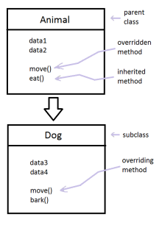

* + - 1. Multiple inheritance

Multiple inheritance is a feature of some object-oriented computer programming languages in which an object or class can inherit features from more than one parent object or parent class. It is distinct from single inheritance, where an object or class may only inherit from one particular object or class.

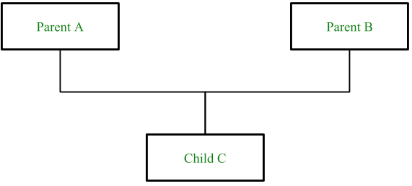

* + - 1. UML

In the aggregate, UML diagrams describe the boundary, structure, and the behavior of the system and the objects within it. UML is **not a programming language** but there are tools that can be used to generate code in various languages using UML diagrams. UML has a direct relation with object-oriented analysis and design.

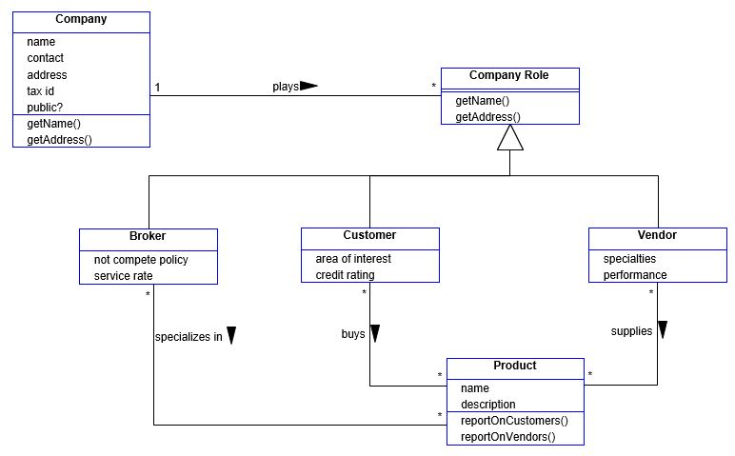

* + - 1. UML class diagram

In software engineering, a class diagram in the Unified Modeling Language (UML) is a type of static structure diagram that describes the structure of a system by showing the system's classes, their attributes, operations (or methods), and the relationships among objects.

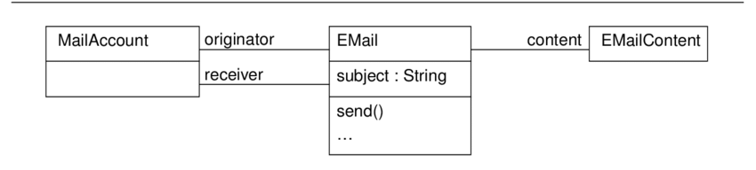

* 1. 2. True or false?

1. The practice of procedural programming is centered on the creation of objects.

True

1. Object reusability has been a factor in the increased use of object-oriented programming.

True

1. It is a common practice in object-oriented programming to make all of a class’s data attributes accessible to statements outside the class.

True

1. Class methods do not have to have a self-parameter.

False

1. Starting an attribute name with two underscores will hide the attribute from code outside the class.

True

1. You cannot directly call the __str__ method.
   1. True

3. Answer the following question: When you model using UML diagrams, why is it important to follow the UML syntax strictly?

It is important that everyone understands the diagrams correctly.

UML diagrams can be used as a way to visualize a project before it takes place or as documentation for a project afterward. But the overall goal of UML diagrams is to allow teams to visualize how a project is or will be working, and they can be used in any field, not just software engineering.

## Test report

|  |  |  |  |
| --- | --- | --- | --- |
| **Task** | **Input / action** | **Desired output** | **Actual output (use red color if desired output != actual output)** |
| **4** | User enters the following information:  OnePlus  8T  850 | Enter the cellpone manufact: OnePlus  Enter the cellpone model: 8T  Enter the cellpone retail price: 850  Here is the data that you provided:  Manufacturer: OnePlus  Model number: 8T  Retail price: 850 | Enter the cellpone manufact: OnePlus  Enter the cellpone model: 8T  Enter the cellpone retail price: 850  Here is the data that you provided:  Manufacturer: OnePlus  Model number: 8T  Retail price: 850 |
|  | | | |
| **5** |  |  |  |
|  | | | |
| **5** | User enters the following information:  OnePlus  8T  850  -1  9  5 | Enter the cellpone manufact: OnePlus  Enter the cellpone model: 8T  Enter the cellpone retail price: 850  Enter the cellpone id: -1  Enter phone id between 1-6.  Enter the cellpone retail price: 9  Enter phone id between 1-6.  Enter the cellpone retail price: 5  Here is the data that you provided:  Manufacturer: OnePlus  Model number: 8T  Retail price: 850  Id: 5 | Rolling the dice...  The dice number: 1  The dice coloris: Brown  The Dice feature is: Fluffy |
|  | | | |
| **6** | User enter 3 phones information and then program print the information. | Enter the cellpone manufact: OnePlus  Enter the cellpone model: 8T  Enter the cellpone retail price: 850  Enter the cellpone id: 1  Enter 2. phone information.  Enter the cellpone manufact: Apple  Enter the cellpone model: 8  Enter the cellpone retail price: 450  Enter the cellpone id: 5  Enter 3. phone information.  Enter the cellpone manufact: Nokia  Enter the cellpone model: 530  Enter the cellpone retail price: 89  Enter the cellpone id: 6 | Phone1. information:  Manufacturer: OnePlus  Model number: 8T  Retail price: 850  Id: 1  Phone2. information:  Manufacturer: Apple  Model number: 8  Retail price: 450  Id: 5  Phone3. information:  Manufacturer: Nokia  Model number: 530  Retail price: 89  Id: 6 |
|  | | | |
| **7** | User runs the program  <Run the program a couple of times so that you get **every player to win** at least once. Program shows winner’s phone> |  | Enter 1. phone information.  Enter the cellpone manufact: Apple  Enter the cellpone model: 6  Enter the cellpone retail price: 304  Enter 2. phone information.  Enter the cellpone manufact: Nokia  Enter the cellpone model: Lumia  Enter the cellpone retail price: 230  Enter 3. phone information.  Enter the cellpone manufact: Apple  Enter the cellpone model: 9  Enter the cellpone retail price: 1009  Enter 4. phone information.  Enter the cellpone manufact: OnePlus  Enter the cellpone model: 8T  Enter the cellpone retail price: 560  Enter 5. phone information.  Enter the cellpone manufact: Doro  Enter the cellpone model: Senior  Enter the cellpone retail price: 78  Enter 6. phone information.  Enter the cellpone manufact: OnePlus  Enter the cellpone model: 4  Enter the cellpone retail price: 340  Phone id:0 information:  Manufacturer: Apple  Model number: 6  Retail price: 304  Phone id:1 information:  Manufacturer: Nokia  Model number: Lumia  Retail price: 230  Phone id:2 information:  Manufacturer: Apple  Model number: 9  Retail price: 1009  Phone id:3 information:  Manufacturer: OnePlus  Model number: 8T  Retail price: 560  Phone id:4 information:  Manufacturer: Doro  Model number: Senior  Retail price: 78  Phone id:5 information:  Manufacturer: OnePlus  Model number: 4  Retail price: 340  Karolina dice number is 4  Jorma dice number is 1  Tero dice number is 3  Jorma has a small number of dice.  Karolina dice number is 5  Tero dice number is 3  Tero has a small number of dice.  Winner is Karolina!  Winner phone is OnePlus |
|  | | | |
| **8** | The program prints the data entered in the parameters. |  | Make: Tesla, model: Model 3, mileage: 340, price 76 900, color: red, maximum_load_limit: 5300, size of trunk: 350 |
|  | | | |
| **9** | The user runs the program. |  | Uni-Kukka ei mahu!  Simo ei mahu!  Bambi laitettu auton kyytii! |
|  | | | |